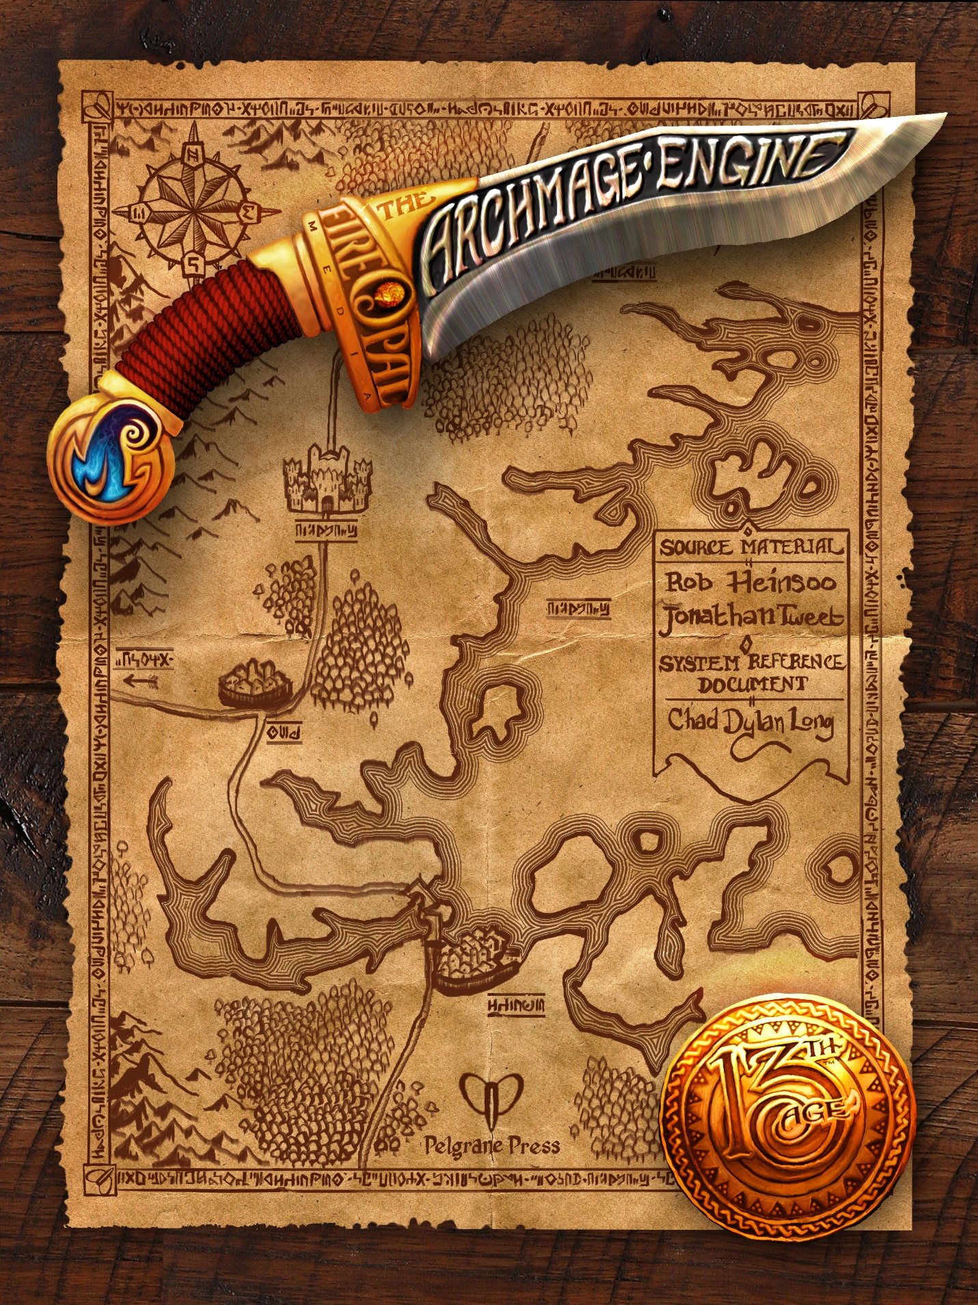

Running the Game
This section has instruction for the GM on running the game.

Using Icon Relationships
For basic icon relationship rules, see Icon Relationships.
As a GM, use a PCs’ icon relationships three different ways: for starting a session, for in-game dramatic events, and for discovery and surprise.

Rolling Relationships at the Start of a Session
All players roll their PC’s icon relationship dice at the start of each session, and everybody sees the results. As usual, rolling a 6 with an icon die provides an unambiguous advantage. Rolling a 5 provides a similar advantage, but the benefit is balanced by complications and obligations that advance the story. By the end of the session, each 6 or 5 should contribute to the story somehow, either at the GM’s or player’s initiative.
The GM uses the results to think ahead about which icons come to the fore this session. Players use the results to start thinking about how their icon relationships might manifest in the story.
As GM, you bear most of the burden of improvising story elements based on the PCs’ icon relationship results. Your players may have great suggestions, but it’s on you to weave them together with the story elements and battles you have already prepared…or are planning to improvise on the spot.

Rolling New Story-guide Dice Mid-session
Story events and talents can create new icon relationships in the middle of play. Allow players to roll newly acquired icon dice right away as if they’d had them at the start of the session.

Icon Relationship Rolls as Dramatic Events
Players roll all of their relationship dice for a particular icon when their PCs are confronting that icon’s representatives, agents, or minions. The GM decides when an event-based roll is called for.
Story-guide rolls should occur most every session. Event-based rolls rise out of circumstances during play.
It’s never the player’s choice to roll icon relationship dice for dramatic events. When new circumstances and dramatic events force or suggest interactions or confrontations with forces or situations associated with a particular icon, the GM can call for an icon relationship roll as a shorthand guide to the dramatic results of the situation.

Rolling a 5 with Icon Events
Getting a 5 on an icon relationship check moves the story forward, just like a 6 does, but it also generates a complication. A 5 means both good and bad results. The negative result might be secret, it might be delayed, and it might be nothing more than a promise until you figure out what it really means.

Discovery & Surprise
At the GM’s option, players may roll icon relationship dice to find out which icons are involved in a plot element, if any. When the characters have slalomed onto paths and adventures you did not anticipate, icon relationship rolls can serve as an idea generator with mechanics that everyone already understands.
Discovery dice aren’t interpreted as positively as other icon relationship rolls. You’re using the icon dice more to determine whether an icon has a stake in what’s involved, not necessarily whether the situation is going to work to a PC’s advantage.
You’ll probably use this style of roll most often when the characters have gone off your map, chasing enemies you hadn’t anticipated, seeking treasures you referred to earlier without having a clear idea about, and taking forest paths you hadn’t been aware existed. GMs who enjoy being surprised by new developments may opt for discovery rolls before improvising the consequences of the PCs’ unexpected steps.
Using icon relationship rolls from one or more characters keeps the new developments relevant to the players and possibly relevant to the overarching plot.

Environments
Any place in the game world that a player might want to make a skill check is an environment, of which there are three tiers: adventurer, champion, and epic.
Adventurer environments are for level 1-3 characters: city streets, wilderness areas, shallow dungeons, regular old ruins, and that sort of thing.
Champion environments are for level 4-6 characters: deeper dungeons, danker swamps, guarded gates of the big cities, and those sorts of places.
Epic environments are for level 7+ characters. They are typically related to icons, unique villains, deep underworld locations, the most forbidding peaks, the upper reaches of the world, and so on.
The GM determines the environs where the adventure takes place.

Environment Chart by Level
Level | Type of Environment
1–3 | Always adventurer
4 | Mostly adventurer, some champion
5 | Half adventurer, half champion
6 | Mostly champion, some adventurer
7 | Mostly champion, some epic
8 | Half champion, half epic
9 | Mostly epic, some champion
10 | Always epic

Environment DCs for Skill Checks
The environment the PCs are in determines the DC of skill checks and other challenges they may face.

Adventurer-tier Skill Check DCs
Task | DC
Normal task | DC 15
Hard task | DC 20
Ridiculously hard task | DC 25

Champion-tier Skill Check DCs
Task | DC
Normal task | DC 20
Hard task | DC 25
Ridiculously hard task | DC 30

Epic-tier Skill Check DCs
Task | DC
Normal task | DC 25
Hard task | DC 30
Ridiculously hard task | DC 35

Impromptu Damage
When you need to determine how much damage some effect deals, use the chart below, basing the damage on two things: the environment, and whether the damage affects one character or many.

Traps & Obstacles
As shown in the chart below, attack rolls for traps and other features of the environment follow the same mathematical model as DCs for skill checks.
Use the skill check DC on the table to give you a general guideline for PCs attempting to disarm a trap (once they notice that there is a trap). Failure means the trap will trigger.

Skill Check DCs, Trap/Obstacle Attacks & Impromptu Damage by Environment
Tier | Degree of Challenge | Skill Check DC | Trap or Obstacle Attack Roll vs. AC/PD/MD | Impromptu Damage (Single Target) | Impromptu Damage (Multiple Targets)
Adventurer | Normal | 15 | +5 | 2d6 or 3d6 | 1d10 or 1d12
Adventurer | Hard | 20 | +10 | 3d6 | 1d12
Adventurer | Ridiculously hard | 25 | +15 | 3d6 or 4d6 | 1d12 or 2d8
Champion | Normal | 20 | +10 | 4d6 or 4d8 | 2d10 or 2d12
Champion | Hard | 25 | +15 | 4d8 | 2d12
Champion | Ridiculously hard | 30 | +20 | 4d8 or 2d20 | 2d12 or 3d10
Epic | Normal | 25 | +15 | 2d20 or 3d20 | 3d12 or 4d10
Epic | Hard | 30 | +20 | 3d20 | 4d10
Epic | Ridiculously hard | 35 | +25 | 3d20 or 4d20 | 4d10 or 4d12

Building Battles
For adventure tier, levels 1-4, start with one enemy creature of the party’s level per PC. At champion tier, levels 5-7, start with one enemy creature per PC, with each creature being one level higher than the PCs. At epic tier, levels 8–10, the monsters should weigh in at two levels above the PCs if they appear in equal numbers.
Lower-level monsters count as fractions of an adventurer-level monster, and higher-level monsters count as multiples. See the monster equivalents chart below.

Monster Equivalents
Monster Level vs. Party Level (Adventurer) | Monster Level vs. Party Level (Champion) | Monster Level vs. Party Level (Epic) | Normal counts as… | Mook counts as… | Large counts as… | Huge counts as…
2 levels lower | 1 level lower | SAME LEVEL | 0.5 | 0.1 | 1 | 1.5
1 level lower | SAME LEVEL | 1 level higher | 0.7 | 0.15 | 1.5 | 2
SAME LEVEL | 1 level higher | 2 levels higher | 1 | .2 | 2 | 3
1 level higher | 2 levels higher | 3 levels higher | 1.5 | .3 | 3 | 4
2 levels higher | 3 levels higher | 4 levels higher | 2 | .4 | 4 | 6
3 levels higher | 4 levels higher | 5 levels higher | 3 | .6 | 6 | 8
4 levels higher | 5 levels higher | 6 levels higher | 4 | .8 | 8

Mooks
At champion and epic tier, it takes 5 mooks to equal one standard creature. At first and second level, use 3 mooks as a standard creature if the mooks are the same level, an equivalent of .33. At third and fourth level, use up to four mooks per monster, or .25.

Large Monsters
A large (or double-strength) monster counts as 2 standard monsters.

Huge Monsters
A huge (or triple-strength) monster counts as 3 standard monsters.

Monster Special Abilities
When you use monsters with especially nasty special abilities, be aware of the increased threat that they represent and take that into account.

Unfair Encounters
To make the battle more difficult, consider outfitting the monsters in the battle with these features:
- Potent powers
- Nastier specials
- Weight of numbers
- Reinforcements
- Advantageous terrain

Full Heal-ups
A party should get a full heal-up after approximately 4 regular battles, 3 hard battles, or 2 regular battles and 1 very hard battle.
For storytelling, try to sync full heal-ups with an appropriate event in the game world.
If the PCs find some special source of healing when they don’t deserve a full heal-up yet, allow them to get one or two recoveries back and to make some extra recharge rolls.
If the party is able to rest and decides to heal-up ahead of time, they suffer a campaign loss. The story moves along, but the situation in the campaign gets noticeably worse for the party (at the GM’s discretion).

Leveling Up
Characters advance a level after three or four full heal-ups, i.e. between twelve and sixteen serious battles. The whole party levels up together.

Benefits of Leveling Up
When you level up, you get these benefits:
- +1 to attacks, defenses, and skill checks.
- An additional die of damage with weapon attacks.
- More hit points (by class).
- An additional feat. Choose any feat whose prerequisites your character satisfies. Feats are classed as adventurer (can be chosen at any level), champion (can be chosen at level 5+), and epic (can be chosen at level 8+).
- The ability to wield an additional magic item. (See Magic Item Personalities & Quirks.)
- At 4th level, 7th level, and 10th level, you add +1 to three different ability scores.
- At 5th level and 8th level, gain an additional icon relationship point, and possibly more talents depending on your class.
- Possibly more powers and spells, and possibly an increase in their strength. (See Classes.)

Incremental Advance
After each session that goes well, the GM awards the players an incremental advance.
When you gain an incremental advance, choose one of the traits of your next level to receive immediately (if available) instead of waiting until you level up. You’re not stuck with your choice, however, once you do level up.
You can take each incremental advance only once (except power/spell, see below). The advancement choices are:

Ability Score Bonuses
As a 4th-, 7th-, or 10th-level incremental advance, you can choose +1 in three of your ability scores.

Feat
Choose a feat. For the purposes of this feat, your level is one higher than normal. When you level up, you can switch this feat out for another feat of your choice.

Hit Points
Your maximum hit points increase as if you were one level higher. If you’re presently damaged while mid-adventure, your current hit points increase by the same amount.

Magic Item
You can wield an additional magic item as if you were 1 level higher.

Power or Spell
Choose a single power or spell that you could take at your next level. If you have a choice of multiple powers or spells, then you can take this increment multiple times to match. If you must replace a lower-level spell with a higher-level spell, you cannot replace a spell that has been expended.

Skills
Add +1 to all skill checks.

Talent
If your class gains a new talent at the next level, you can take that talent as an incremental advance at 4th or 7th level.

Icon Relationship Points
As a 4th or 7th level incremental advance, with the GM’s permission, you can choose a new icon relationship point that you would get at 5th or 8th level.

No Attack or Defense Bonuses
You only get these bonuses when you level up.

Loot: Treasure Rewards
Use the guidelines that follow to decide how many gold pieces and magic items to reward to successful adventurers.
The majority of treasure reaches the PCs one of two ways (a) as loot from climactic battles, or (b) as rewards after or before an adventure from a PC’s icon connections.

Gold Piece Rewards
The table below lists the highest amount of gold pieces you should consider awarding to each character in the course of an adventuring day. Rewarding less gold is fine.

GP per Full Heal-Up
PC Level | GP per Character
1 | 100
2 | 125
3 | 175
4 | 210
5 | 250
6 | 325
7 | 425
8 | 500
9 | 650
10 | 850

Optional No Math System
Each player rolls a d20 and checks the table below. Results are not cumulative; what you roll is what you get.

Loot per Heal-Up
Roll | Loot
1–2 | Useless stuff, fake potions, costume jewelry, nothing gained.
3–4 | One healing potion, lower tier.
5–10 | One healing potion from PC’s tier.
11–15 | Two potions/oils/runes of PC’s choice from PC’s tier.
16–20 | Three potions/oils/runes of PC’s choice from PC’s tier.

Rituals
Rituals are spells cast outside of combat for various free-form magical effects. Clerics and wizards learn ritual magic by default; other spellcasters can learn it by taking the Ritual Casting feat.

Casting a Ritual
To cast a spell as a ritual:
- Choose the spell that will be used and expended by the ritual.
- Tell the GM what you are trying to accomplish and gather necessary ingredients for the ritual.
- Spend 1d4 minutes/quarter-hours/hours (as determined by the GM) preparing and casting the ritual. You can’t cast other spells during this period. A PC taking damage won’t necessarily end the ritual, but it will be ruined if a character falls unconscious or launches an attack of their own.
- Make a skill check using one of your magical backgrounds and the ability score the GM deems appropriate. Use the standard DC targets (or a special DC set by the GM), depending on your tier and the results you’re hoping for. The higher the level of the spell consumed by the ritual, the greater the effect.
No matter the outcome, the spell is expended until your next full heal-up.

Determining Results
Choose outcomes that are outgrowths of the spell’s normal effects. The effects don’t have to play within the usual constraints of the magic system, and they don’t have to be taken as a precedent for future rituals.
Failure should fail forward.
The High Arcana talent of the wizard allows you to cast a ritual in a matter of rounds instead of minutes, but it still needs the required components.

