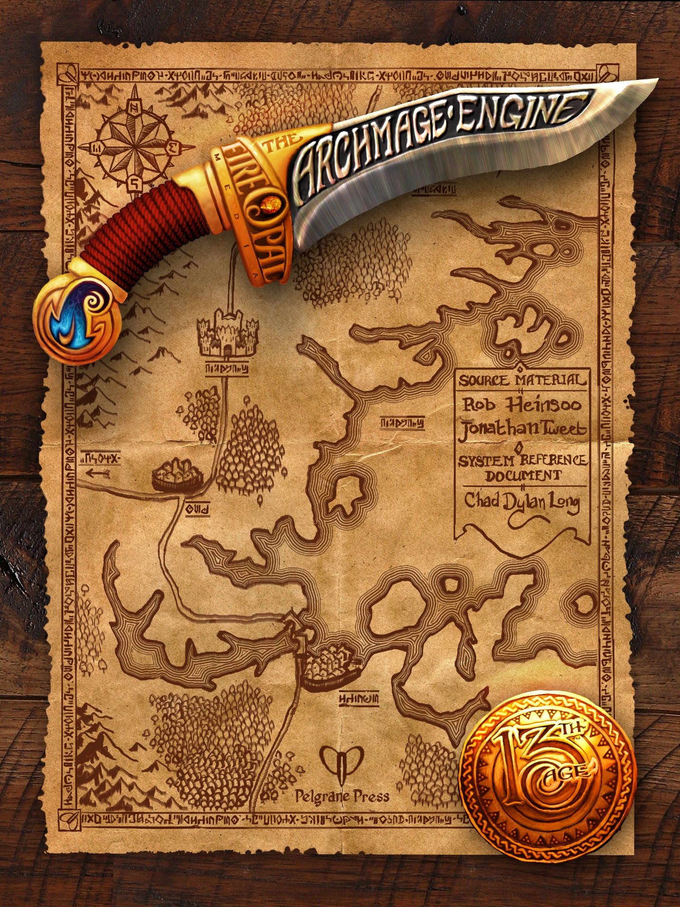

Legal
The 13th Age Archmage Engine describes the rules of 13th Age, the 13th Age Bestiary, and 13 True Ways that you may incorporate, wholly or in part, into a derivative work.
In short, we’ll describe the rules and mechanics that we use for 13th Age (Open Content), then you can adopt the ones you like and leave the ones you don’t. Just don’t use any intellectual property that is not specifically part of the 13th Age Archmage Engine (Product Identity).

Product Identity
The following items are hereby identified as Product Identity, as defined in the Open Game License 1.0a, Section 1(e), and are not Open Content: All trademarks, registered trademarks, proper names (characters, icons, etc.), dialogue, plots, storylines, locations, characters, artworks, and trade dress. (Elements that have previously been designated as Open Game Content are not included in this declaration.)

Open Content
Except for material designated as Product Identity (see above), the game mechanics of this Fire Opal Media game product are Open Game Content, as defined in the Open Game License version 1.0a Section 1(d). No portion of this work other than the material designated as Open Game Content may be reproduced in any form without written permission.

Open Game License
OPEN GAME LICENSE Version 1.0a
The following text is the property of Wizards of the Coast, Inc. and is Copyright 2000 Wizards of the Coast, Inc. ("Wizards"). All Rights Reserved.
- Definitions: (a)"Contributors" means the copyright and/or trademark owners who have contributed Open Game Content; (b)"Derivative Material" means copyrighted material including derivative works and translations (including into other computer languages), potation, modification, correction, addition, extension, upgrade, improvement, compilation, abridgment or other form in which an existing work may be recast, transformed or adapted; (c) "Distribute" means to reproduce, license, rent, lease, sell, broadcast, publicly display, transmit or otherwise distribute; (d)"Open Game Content" means the game mechanic and includes the methods, procedures, processes and routines to the extent such content does not embody the Product Identity and is an enhancement over the prior art and any additional content clearly identified as Open Game Content by the Contributor, and means any work covered by this License, including translations and derivative works under copyright law, but specifically excludes Product Identity. (e) "Product Identity" means product and product line names, logos and identifying marks including trade dress; artifacts; creatures characters; stories, storylines, plots, thematic elements, dialogue, incidents, language, artwork, symbols, designs, depictions, likenesses, formats, poses, concepts, themes and graphic, photographic and other visual or audio representations; names and descriptions of characters, spells, enchantments, personalities, teams, personas, likenesses and special abilities; places, locations, environments, creatures, equipment, magical or supernatural abilities or effects, logos, symbols, or graphic designs; and any other trademark or registered trademark clearly identified as Product identity by the owner of the Product Identity, and which specifically excludes the Open Game Content; (f) "Trademark" means the logos, names, mark, sign, motto, designs that are used by a Contributor to identify itself or its products or the associated products contributed to the Open Game License by the Contributor (g) "Use", "Used" or "Using" means to use, Distribute, copy, edit, format, modify, translate and otherwise create Derivative Material of Open Game Content. (h) "You" or "Your" means the licensee in terms of this agreement.
- The License: This License applies to any Open Game Content that contains a notice indicating that the Open Game Content may only be Used under and in terms of this License. You must affix such a notice to any Open Game Content that you Use. No terms may be added to or subtracted from this License except as described by the License itself. No other terms or conditions may be applied to any Open Game Content distributed using this License.
- Offer and Acceptance: By Using the Open Game Content You indicate Your acceptance of the terms of this License.
- Grant and Consideration: In consideration for agreeing to use this License, the Contributors grant You a perpetual, worldwide, royalty-free, non-exclusive license with the exact terms of this License to Use, the Open Game Content.
- Representation of Authority to Contribute: If You are contributing original material as Open Game Content, You represent that Your Contributions are Your original creation and/or You have sufficient rights to grant the rights conveyed by this License.
- Notice of License Copyright: You must update the COPYRIGHT NOTICE portion of this License to include the exact text of the COPYRIGHT NOTICE of any Open Game Content You are copying, modifying or distributing, and You must add the title, the copyright date, and the copyright holder's name to the COPYRIGHT NOTICE of any original Open Game Content you Distribute.
- Use of Product Identity: You agree not to Use any Product Identity, including as an indication as to compatibility, except as expressly licensed in another, independent Agreement with the owner of each element of that Product Identity. You agree not to indicate compatibility or co-adaptability with any Trademark or Registered Trademark in conjunction with a work containing Open Game Content except as expressly licensed in another, independent Agreement with the owner of such Trademark or Registered Trademark. The use of any Product Identity in Open Game Content does not constitute a challenge to the ownership of that Product Identity. The owner of any Product Identity used in Open Game Content shall retain all rights, title and interest in and to that Product Identity.
- Identification: If you distribute Open Game Content You must clearly indicate which portions of the work that you are distributing are Open Game Content.
- Updating the License: Wizards or its designated Agents may publish updated versions of this License. You may use any authorized version of this License to copy, modify and distribute any Open Game Content originally distributed under any version of this License.
- Copy of this License: You MUST include a copy of this License with every copy of the Open Game Content You Distribute.
- Use of Contributor Credits: You may not market or advertise the Open Game Content using the name of any Contributor unless You have written permission from the Contributor to do so.
- Inability to Comply: If it is impossible for You to comply with any of the terms of this License with respect to some or all of the Open Game Content due to statute, judicial order, or governmental regulation then You may not Use any Open Game Material so affected.
- Termination: This License will terminate automatically if You fail to comply with all terms herein and fail to cure such breach within 30 days of becoming aware of the breach. All sublicenses shall survive the termination of this License.
- Reformation: If any provision of this License is held to be unenforceable, such provision shall be reformed only to the extent necessary to make it enforceable.
- COPYRIGHT NOTICE
Open Game License v 1.0a. Copyright 2000, Wizards of the Coast, Inc.
System Reference Document. Copyright 2000, Wizards of the Coast, Inc.; Authors: Jonathan Tweet, Monte Cook, Skip Williams, based on material by E. Gary Gygax and Dave Arneson.
13th Age. Copyright 2013, Fire Opal Media; Authors: Rob Heinsoo, Jonathan Tweet, based on material by Jonathan Tweet, Monte Cook, and Skip Williams.
13th Age Bestiary. Copyright 2014, Fire Opal Media and Pelgrane Press Ltd; Authors: Ryven Cedyrlle, Rob Heinsoo, Kenneth Hite, Kevin Kulp, ASH LAW, Cal Moore, Steve Townshend, Rob Watkins, Rob Wieland.
13 True Ways. Copyright 2014, Fire Opal Media, Inc.; Authors: Rob Heinsoo, Jonathan Tweet, Robin D. Laws.
Pathfinder RPG Core Rulebook. Copyright 2009, Paizo Publishing, LLC; Author: Jason Bulmahn, based on material by Jonathan Tweet, Monte Cook, and Skip Williams.
Castles & Crusades, Copyright 2004, Troll Lord Games; Authors: Davis Chenault, Mac Golden.
13th Age Archmage Engine. Copyright 2013-2015, Fire Opal Media. Author: Chad Dylan Long, based on material by Jonathan Tweet, Rob Heinsoo, Ryven Cedyrlle, Kenneth Hite, Kevin Kulp, ASH LAW, Cal Moore, Steve Townshend, Rob Watkins, and Rob Wieland.

13th Age Archmage Engine
Copyright 2013-2015, Fire Opal Media. Author: Chad Dylan Long, based on material by Jonathan Tweet, Rob Heinsoo, Ryven Cedyrlle, Kenneth Hite, Kevin Kulp, ASH LAW, Robin D. Laws, Cal Moore, and Steve Townshend. Edited by Cal Moore and Simon Rogers. Cover art by Cougar George.

Revision History

3.0
Additions:
- 13 True Ways monsters
- 13 True Ways classes
- 13 True Ways multiclassing
- 13 True Ways magic items
- Artifacts (magic items)
- Targeting clarification
- Monster level-up guidelines, and stat adjustments for monster creation
- Underkraken short intro
- Intellect Assassin
Changes:
- Monster List: added 13 True Ways monsters
- Feat Lists: added feat tables for 13 True Ways characters
- Ranger Animal Companion rules
- Level Progression tables of the core classes now have (M) designations
- Useful Magic Items by Class table includes 13 True Ways classes
- Minor changes to sorting of Wands (Magic Items)
- Fixed category for Dire Bear, Hellhound, Ochre Jelly (Monster Reference)
- Fixed capitalization for Couatls (Monster Reference)
- Fixed sizes for Bulette, Jotun Auroch, Volcano Dragon, Elder Swaysong Naga, Elder Sparkscale Naga, Skull of the Beast, Elder Manafang Naga (Monster Reference)
- Fixed names for Fungaloid Creeper, Lammasu Warrior, Remorhaz entries (Monster Reference)
- Fixed role for Winter Beast (Monster Reference)
- Monster List updates…
  - poddling -> podling
  - ghoul: humanoid -> undead
  - slime skull -> slime-skull
  - kobold dog rider -> kobold dog-rider
  - hell hound -> hellhound
  - woven -> the woven
  - flaming skull: small –> normal
  - hydra, 5 heads -> hydra, five-headed
  - hydra, 7 heads -> hydra, seven-headed
  - warp beast -> warped beast
  - intellect assassin: spoiler -> blocker
  - vrock -> vrock (vulture demon)
  - giant vrock -> giant vrock (vulture demon)
  - spider mount: large -> normal
  - sahuagin mutant: 2x -> large
  - hezrou -> hezrou (toad demon)
  - bronze golem: wrecker -> blocker
  - phase spider: wrecker -> spoiler
  - stone golem: ooze -> construct
  - glabrezou -> glabrezou (pincer demon)
  - purple larvae -> purple larva
  - marble golem: 8 -> 9
  - great fang cadre (orc) -> great fang cadre
  - spawn of the master (vampire) -> spawn of the master
  - marilith -> marilith (serpent demon)
  - balor -> balor (flame demon)
- Minor formatting to feat tables (remove bold A C E).
Removals:
- Feat List

2.0
Additions:
- Bestiary monsters and abilities
- Type column to Monster List
- Chuulish symbiotic items
- Shadow Dragon cursed items
- Handsome cover image
Changes:
- Moved creature-specific abilities to those creature headings.
- Removed a reference to 13th Age core book layout.
- Reordered some creatures.
- Changed some instances x2 to 2x.
- Zombie Shuffler entry now has correct type listed.
- Modified legal text for consistency with other media.

1.1
Additions:
- Newly-Risen Ghoul added to Monster Reference.
- Stats for Zombie Shuffler added.
- Attack for Decrepit Skeleton added.
- Added Domain: Knowledge/Lore to Cleric talents.
- Revision History section added.
- Version number and reference to 13th Age Archmage Engine added to the footer.
Changes:
- Moved Invocation of Justice/Vengeance back underneath the Domain: Justice/Vengeance heading (and above the feats).

1.0
Initial release.

