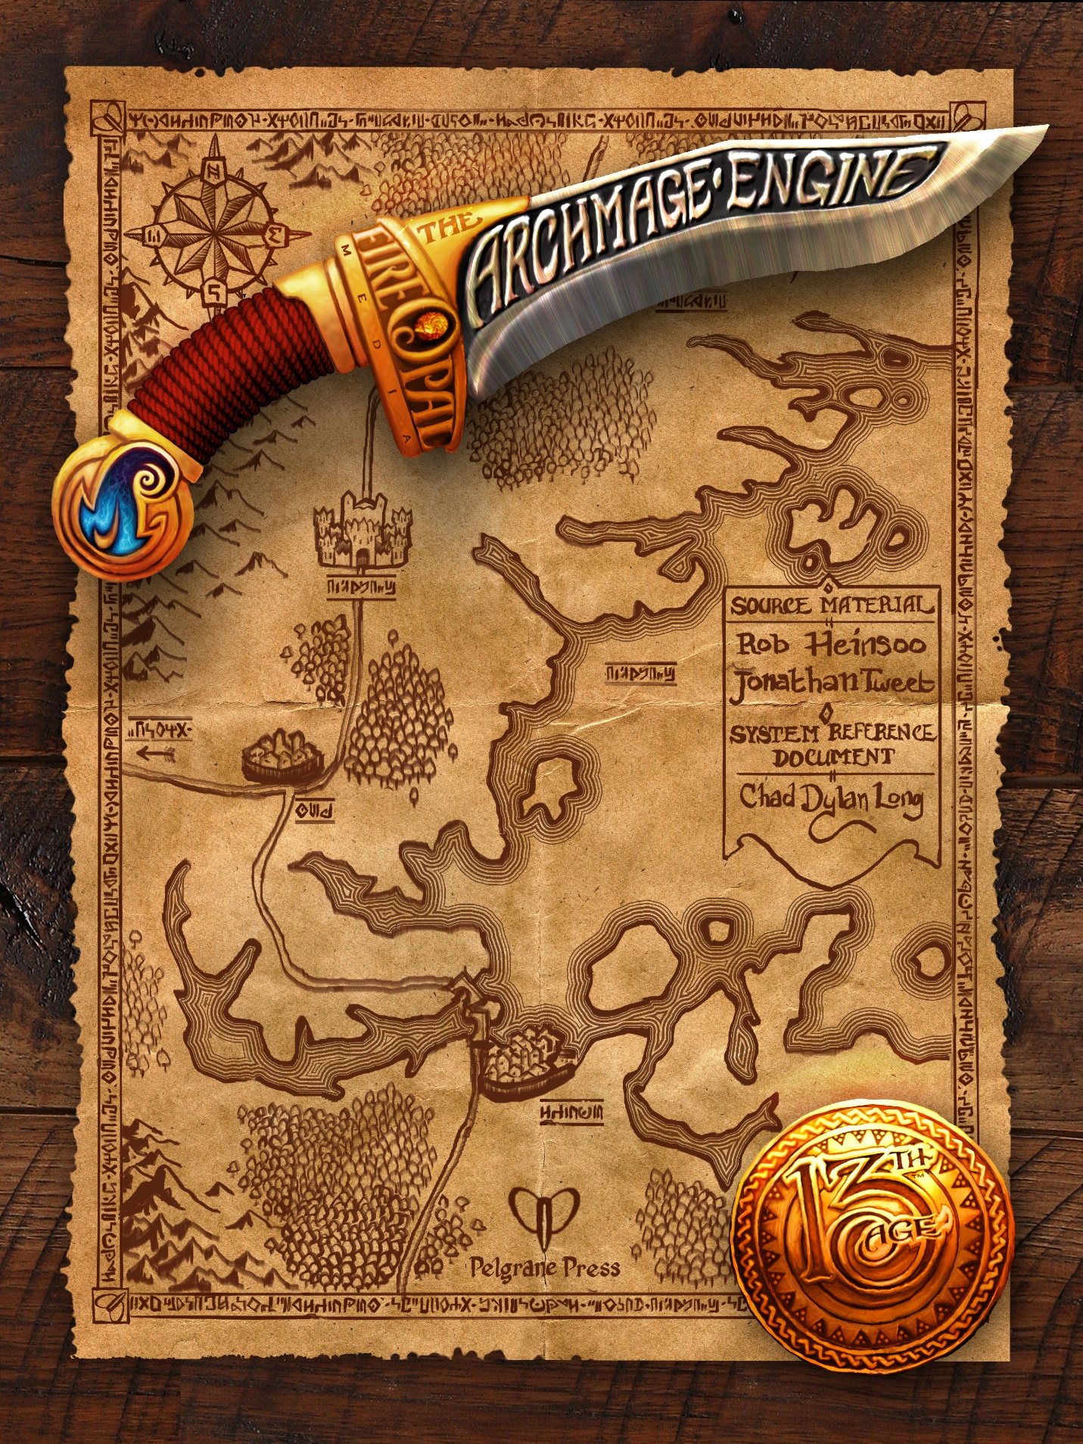

Icons
The 13th Age Archmage Engine supports the concept of icons. An icon is a powerful NPC (non-playable character) that has a strong influence on the world outside of your campaign, yet may indeed aid or oppose your character over the course of your campaign, depending on the relationship your character has with the icon.
Icons have their own story, alignment, and personality. The general knowledge and history about them may vary in depth and accuracy; they may be well-known or mysterious. They have their own relationships with other icons, too, which may be friendly, tolerable, or acrimonious.
Your character may have relationships with certain icons. This relationship, if it exists, can be positive, conflicted, or negative. See Icon Relationships.

